Transfer streaming data from your local file system to HDFS using flume spool directory.

//creation of a folder spool with 2 files say sample1 and sample2

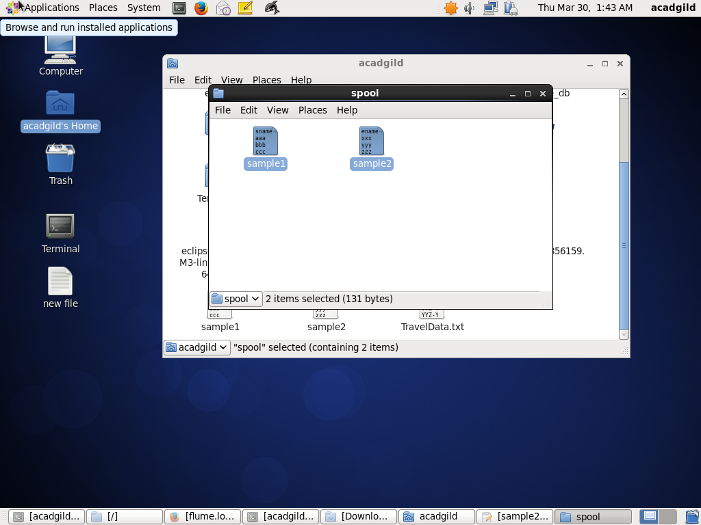

//moving the configuration file into conf folder of flume

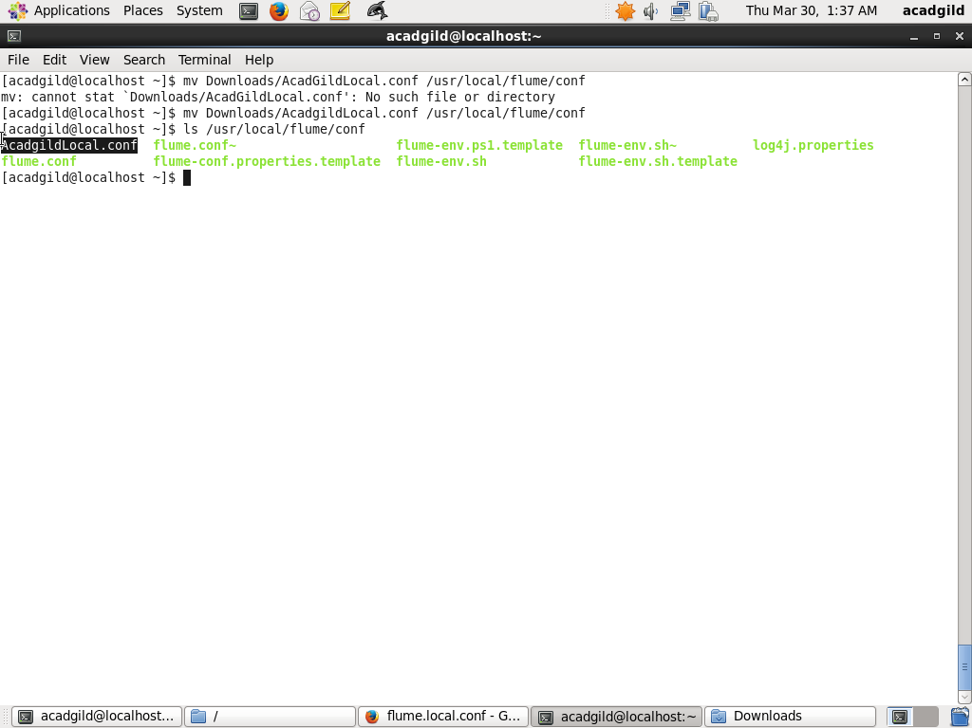

//creation of the output directory

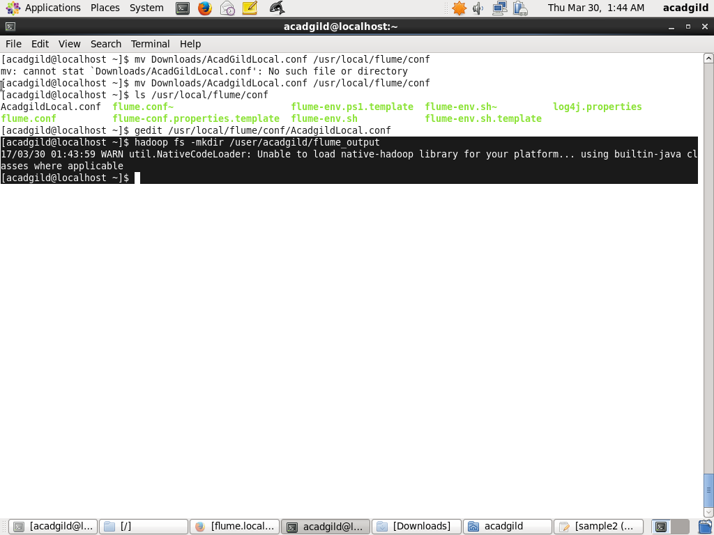

//modification of .conf file according to my path

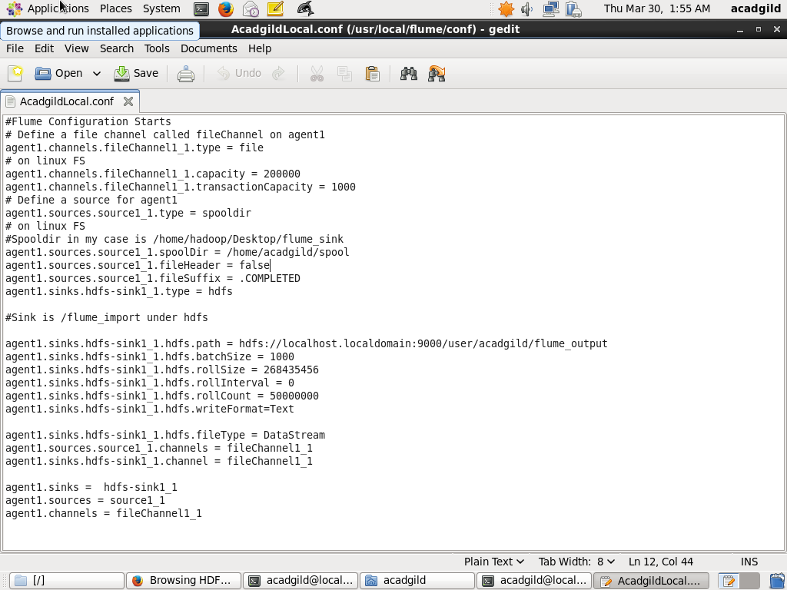

//running the flume agent

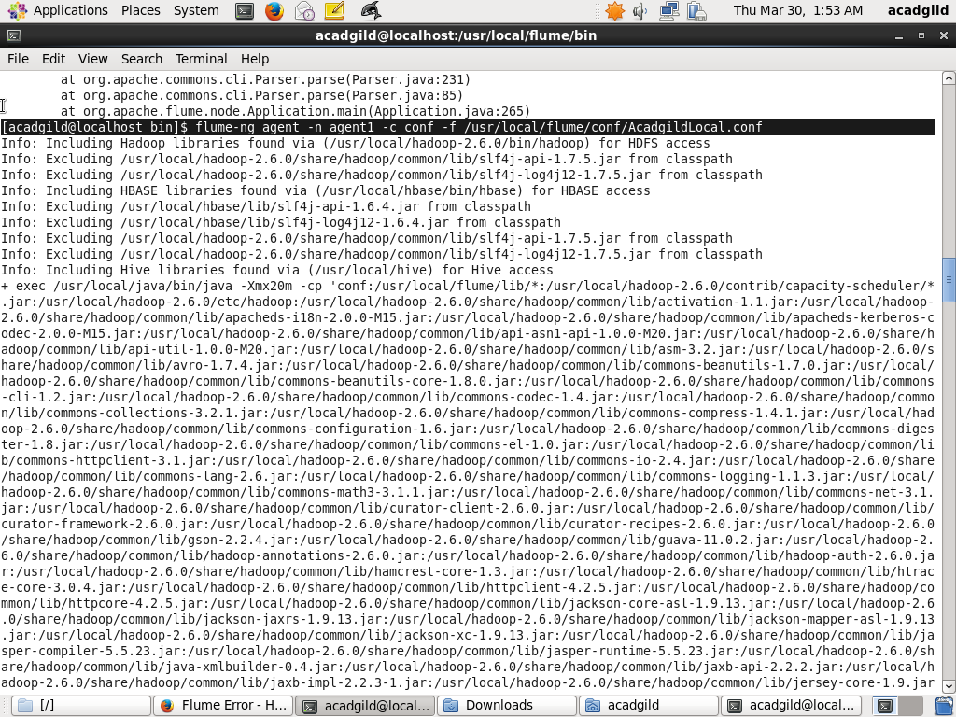

//result

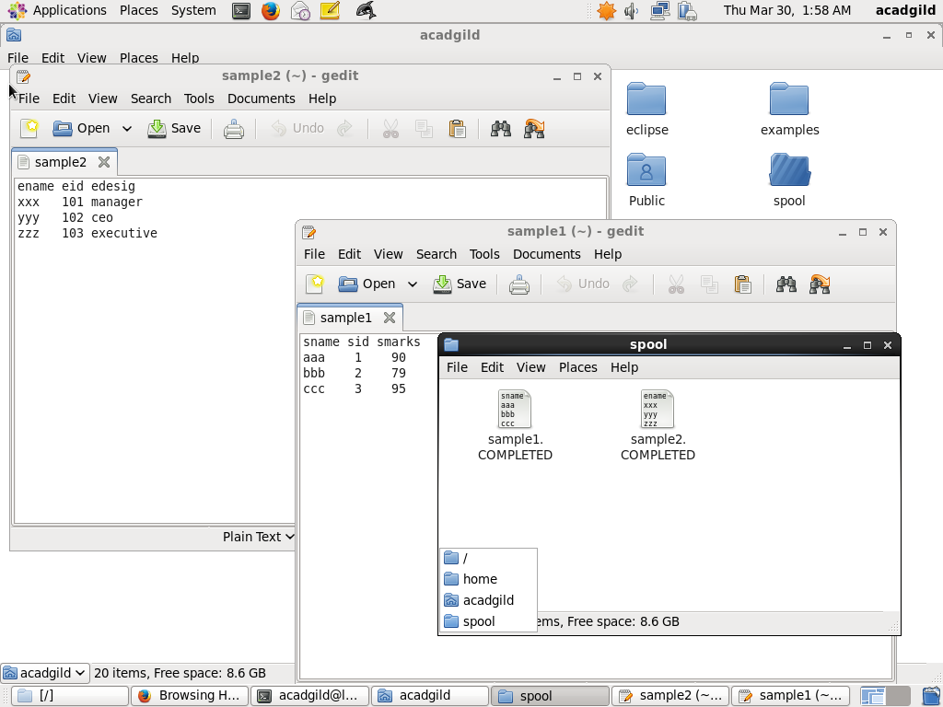

//output stored on hdfs

